#### Capstone-Project -The Battle of Neighborhoods

**Opening a Book Store in NYC**

**Introduction**

**New York City** is provided by a lot of public and private institutions in addition to some of the most important libraries, universities, and research centers in the world.

New York City has many nationally important independent universities and colleges as well as many primary and high schools.

There are about 594,000  university students in New York City attending around 110 universities and colleges. New York State is the nation's largest importer of college students; statistics show that among freshmen who leave their home states to attend college, more come to New York State than any other state[1].

The purpose of this Capstone Project is to find the best locations for opening a book store, I will start by exploring the academic organizations in NY city, however the academic institutions will include different entities such as schools, colleges and Universities.

**Problem statement**

I will start by exploring the academic organizations in NY city, and I will attempt to answer to following questions:

1. Where should I open my book store ?
2. In what Neighborhood and/or borough should I open my book store.

**Data Selection**

To consider the problem I used the below data sources:

**First:**  <https://cocl.us/new_york_dataset>

I used this link merely for giving me general information about NYC's boroughs and neighborhoods as well as the distance between cities.

**Second: Foursquare API**

* I can consider this resource is my primary data resource to gain the most important locational information. Foursquare is a location data provider with information about all venues and events within an area of interest. Such information includes venue names, locations and etc. I am basically depend on this resource as my primary resource of Data.
* After getting the data from .json file, I enjoyed playing with data and exporting it into different [data frames].

### Methodology

* Since I am interested to the academic location in NYC, I've exported my data by using Foursquare API by using my below search query:

I utilized the Foursquare API to explore the boroughs in NYC. I designed the limit as **30 venue** and the radius **1000 meter** for each borough from their given latitude and longitude information.

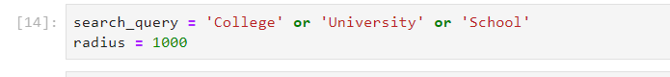

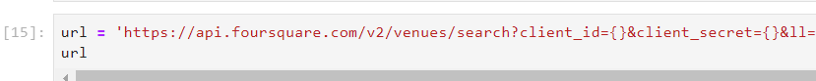

* Exporting the results from.json file into DataFrame:

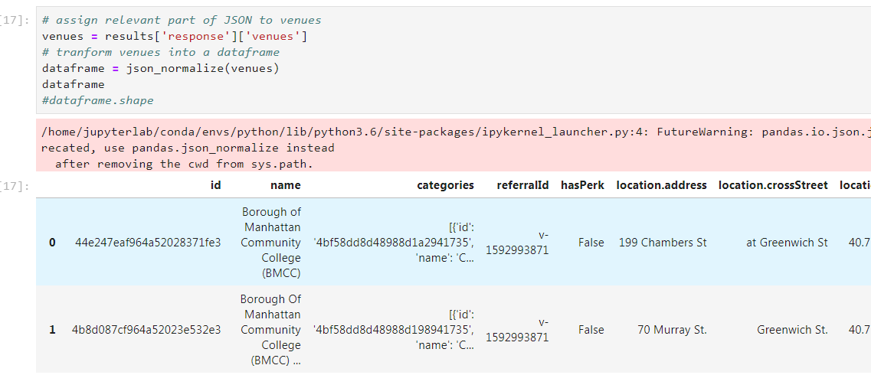

* I used Plot library to generate the below Bar chart that shows different Academic organization (Colleges, Universities, School, etc) along with the number of each category in NY city. Moreover we can see that College Academic Building has the most number of campuses which it can give me a good indicator to establish my book store close to this particular category!

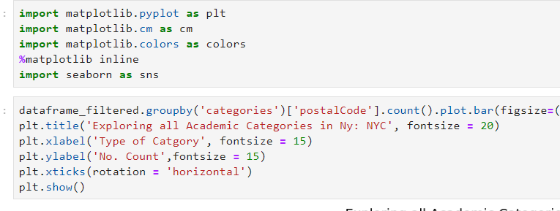

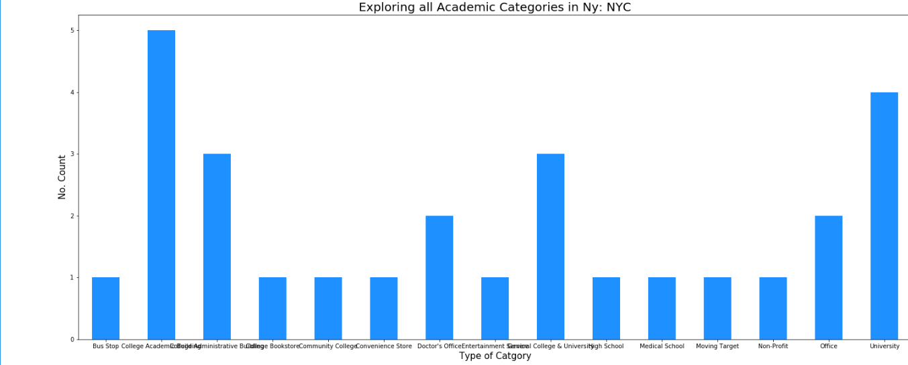

* Filtering the data by using a specified number of Columns

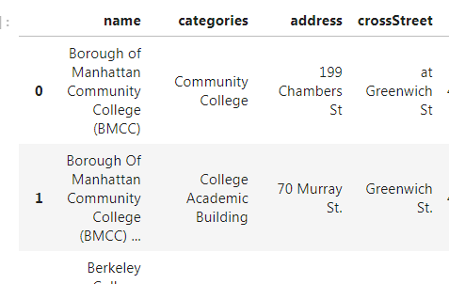

* Since we have a limit number of Foursquare API' calls, I've converted my results into Excel sheet and afterward I've converted it to the Dataframe.

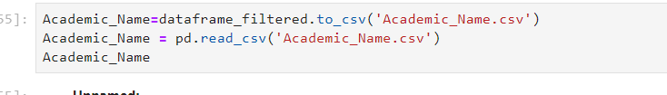

• Finally, the data be will be visually assessed using graphing from various Python libraries such as folium library.

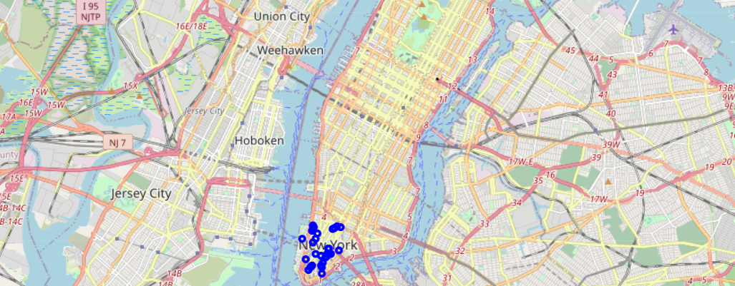

### Results / Conclusion

The "College & University" category will have the most students in this area since too many campuses into the same category. It's very obvious that many universities and campuses are comparing to other academic organizations such as middle and high schools. Therefore I can expect that my book store will be great to target this segments of students.

References

[1] <https://en.wikipedia.org/wiki/Education_in_New_York_City>